Project Name
Alphabet Classification
Teaching-Assistant: Eng/ Ahmed Ashraf
Inception V1 — Advanced Inception Architecture

Reference: Szegedy et al., 2015/2016 (Rethinking
Overview / Core Concept: Inception V1 builds on the original
Inception (v1) by factorizing convolutions (e.g., replacing 5×5 convs with two
3×3, or n×n with 1×n followed by n×1), incorporating Batch Normalization,
label smoothing, and RMSProp optimization. These improvements achieve
higher accuracy without significantly increasing computation.
Forward Pass Flow (High-Level)
Stem: Optimized initial convolution layers reduce spatial dimensions
efficiently.
Inception Modules: Multiple branches with factorized convolutions
(e.g., 1×n followed by n×1) to approximate larger kernels efficiently.
Auxiliary Classifiers: Often removed or simplified; aggressive
regularization and batch normalization are applied throughout.
Classification Head: Global Average Pooling → Dropout → Fully
Connected Layer → Softmax.

Key Details / Hyperparameters

Factorized and asymmetric convolutions reduce computation cost
(e.g., 1×7 → 7×1).
Training strategies such as batch normalization and label smoothing improve
convergence.
Inception V1 is widely used as a high-performance backbone for image
classification.
Advantages and Limitations
Pros: Excellent accuracy-to-computation ratio; widely adopted in practice.
Cons: More complex architecture to implement and tune than standard
residual networks; numerous hyperparameters and module variants make it
harder to modify.
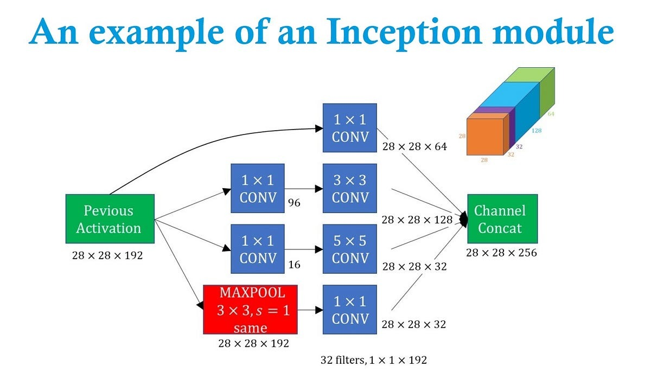
2] VGG19 — Very Deep Convolutional Network

Reference: Simonyan & Zisserman, 2014
Overview / Core Concept :
VGG employs a straightforward and consistent
architecture: sequences of 3×3 convolutional layers (activated by ReLU)
interspersed with occasional 2×2 max-pooling layers. The network’s depth is
increased to enhance its feature representation capabilities . The VGG19,
model specifically contains 19 layers with learnable weights composed of 16
convolutional layers followed by 3 fully connected layers.
Forward Pass Flow (VGG19)
Input: Image of size 224×224×3 (RGB).
Block 1: Two conv layers (3×3, 64 filters) → max-pool (2×2, stride 2)
→ output spatial dimensions halved.
Block 2: Two conv layers (3×3, 128 filters) → max-pool → output halved.
Block 3: Four conv layers (3×3, 256 filters) → max-pool.
Block 4: Four conv layers (3×3, 512 filters) → max-pool.
Block 5: Four conv layers (3×3, 512 filters) → max-pool.
Classification Head: Flatten → FC (4096) → ReLU → Dropout → FC
(4096) → ReLU → Dropout → FC (1000) → Softmax.
Key Details / Hyperparameters:
All convolution layers use 3×3 kernels, stride 1, and padding 1.
Max-pooling uses 2×2 windows with stride 2.
Fully connected layers are large and account for the majority of the
network’s parameters.
Typical input resolution: 224×224.
Total parameters: ~144 million (depends on exact FC layer configuration).
Advantages and Limitations:
Pros: Simple and uniform design, strong performance baseline, easy to
implement and fine-tune for transfer learning.
Cons: Very heavy in terms of parameters and memory; computationally
slow; not ideal for mobile deployment or extremely deep scaling
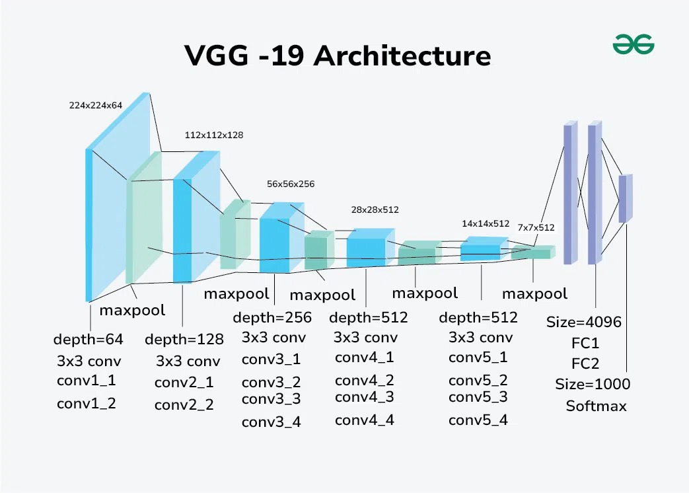
3] ResNet50 — Deep Residual Network
Reference: He et al., 2015 (Deep Residual Learning)
Overview / Core Concept:
ResNet introduces residual (skip) connections, which learn a residual
mapping 𝐹(𝑥) = 𝐻(𝑥 ) − 𝑥
F(x)=H(x)−x instead of directly learning 𝐻 (𝑥)
H(x). This design allows very deep networks (e.g., 50, 101, 152 layers) to be
trained effectively by mitigating the vanishing gradient problem.
Forward Pass Flow (ResNet50)
Input: Image of size 224×224×3.
Initial Layer: Conv (7×7, stride 2) → BatchNorm → ReLU → MaxPool
(3×3, stride 2).
Stage 1 (conv2_x): 3 residual bottleneck blocks, each composed of:
1×1 conv (channel reduction) → BatchNorm → ReLU
3×3 conv (spatial) → BatchNorm → ReLU
1×1 conv (channel expansion) → BatchNorm
Add input via identity or projection shortcut → ReLU
Stage 2 (conv3_x): 4 bottleneck blocks.
Stage 3 (conv4_x): 6 bottleneck blocks.
Stage 4 (conv5_x): 3 bottleneck blocks.
Classification Head: Global Average Pooling → Fully Connected Layer →
Softmax for class probabilities.
Key Details / Hyperparameters:
Bottleneck structure reduces computation while maintaining network depth.
Typical ResNet50 has ~25 million parameters.
Uses Batch Normalization and He initialization.
Shortcuts: Identity connections are used when input/output dimensions
match; projection shortcuts handle dimension changes.
Advantages and Limitations
Pros: Easily trainable for very deep networks, strong accuracy-to-
computation ratio, widely adopted as a backbone for many tasks.
Cons: Still relatively heavy compared to lightweight mobile networks;
residual connections may require task-specific adjustments (e.g., in detection
or segmentation).
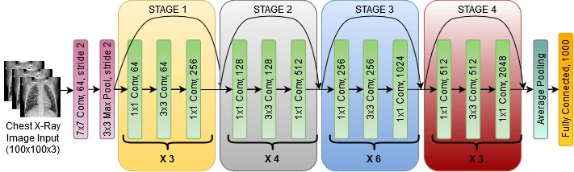

4] MobileNet — Efficient Networks with Depthwise
Separable Convolutions

Reference: Howard et al., 2017 (MobileNets)
Overview / Core Concept:
MobileNet replaces standard convolution layers with depthwise separable
convolutions, which split computation into two steps:
Depthwise convolution: performs spatial convolution independently on each
input channel.
Pointwise convolution (1×1): combines channels across depth.
This decomposition significantly reduces both FLOPs and the number of
parameters. Two main hyperparameters control the model size and accuracy:
width multiplier (α) and resolution multiplier (ρ).
Forward Pass Flow (MobileNet v1)
Input: e.g., 224×224×3 → Initial 3×3 convolution (stride 2).
Repeated Blocks: N × (Depthwise 3×3 conv → BatchNorm → ReLU
→ Pointwise 1×1 conv → BatchNorm → ReLU). Stride can be 1 or 2
depending on the block.
Output: Global Average Pooling → Fully Connected Layer → Softmax for
classification.

Hyperparameters:
Width multiplier 𝛼 ∈ (0,1]
α∈(0,1] scales channel numbers.
Resolution multiplier 𝜌
ρ adjusts input spatial dimensions.
Key Details / Hyperparameters
MobileNet v1 typically uses ReLU (or ReLU6) and Batch Normalization.
α = 1.0 corresponds to the full model; α < 1.0 produces a smaller, lighter
version for mobile applications.
Designed to trade off accuracy for latency and memory efficiency.
Advantages and Limitations
Pros: Extremely lightweight and fast, ideal for mobile and embedded devices.
Cons: Lower accuracy compared to large standard CNNs; later versions
(MobileNetV2/V3) improved efficiency using inverted residual blocks and
other enhancements
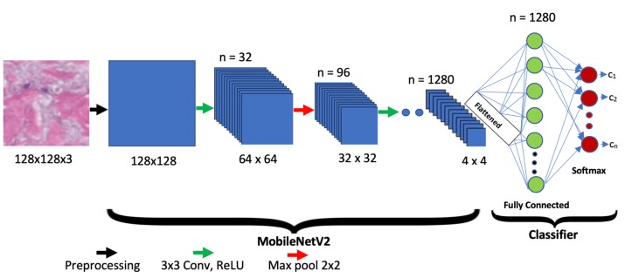
Results for each model:
- VGG19 :
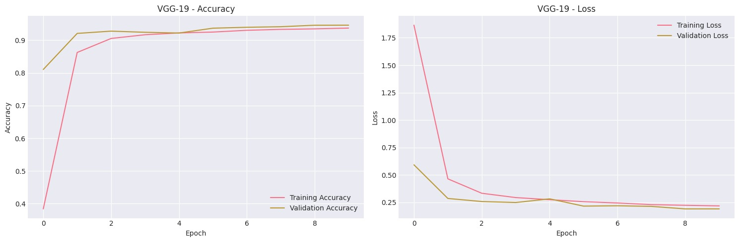
VGG -> accuracy: accuracy: 0.9371 - loss: 0.2178 - val_accuracy:
0.9461 - val_loss: 0.1904 - learning_rate: 1.0000e-04

- MobileNet:
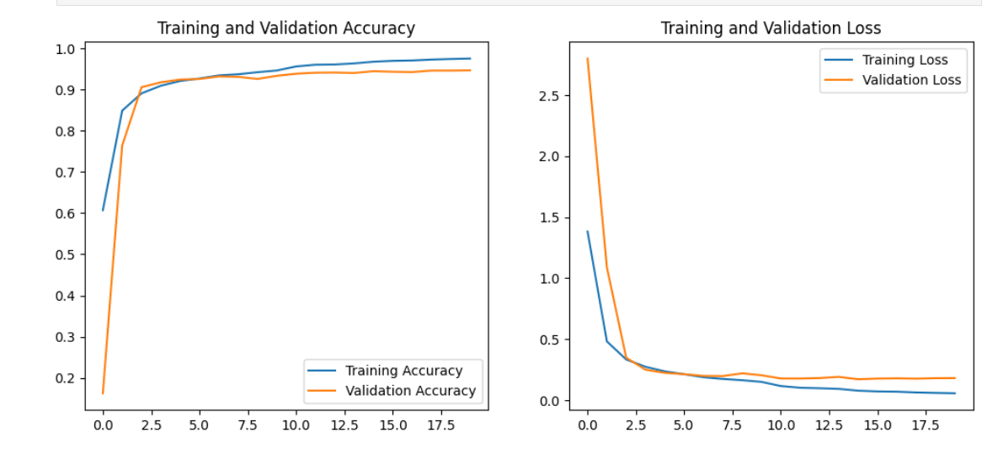
MobileNet : accuracy: 0.9748 - loss: 0.0573 - val_accuracy: 0.9467 –
val_loss: 0.1814 - learning_rate: 6.2500e-06

.

;
else if (A[i]<min2) {
min2 <- A[i];
}
a <- first*second*third;
b <- min1*min2*first;
maxTriplet <- max of (a,b);
print("triplet = " maxTriplet);
}
}

2] Implementation:

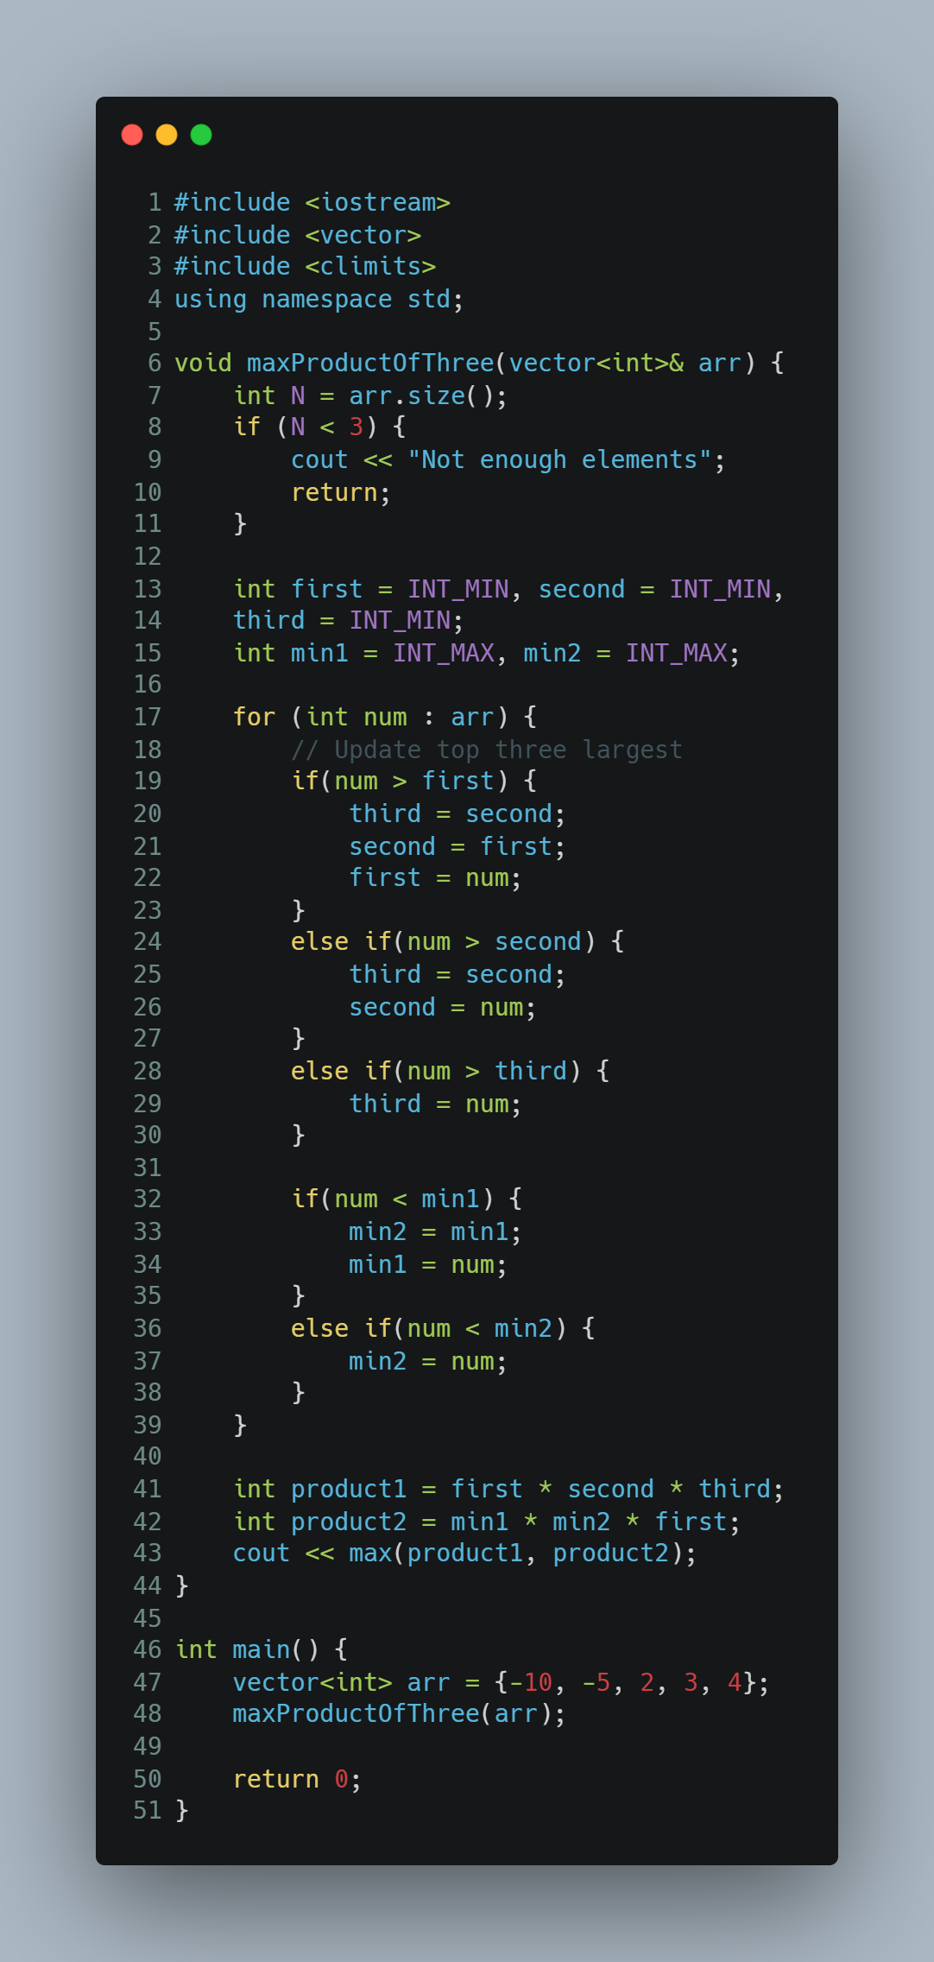
3] Analysis & Complexity:

$T\left(n\right)= \sum_{i=0}^{n-1}{k =k(n-1)}$

$Then :T\left(n\right)=k(n-1)$

$Then$ , the complexity is : 𝚶( n )

Second Algorithm (recursive) :
1] Pseudo code:
MergeSort (A, startA, endA)
if ( startA < endA ) {
mid <- FLOOR(( start A + end ) / 2);
mergeSort( A, start A, mid);
mergeSort( A, mid+1, endA);
n1 <- mid - startA + 1;
n2 <- endA - mid;
LEFT <- new array[n1];
RIGHT <- new array[n2];
for ( i <- 0; i < n1; i++) {
LEFT[i] <- A[startA + i];
}
for (j <- 0; j < n2; j++) {
RIGHT[j] <- A[mid + 1 + j];
}
i <- j <- 0;
k <- startA;
while (i < n1 AND j < n2) {
if (LEFT[i] <= RIGHT[j]) {
A[k] <- LEFT[i];
i++;
}
else {
A[k] <- RIGHT[j];
j++;
}
k++;
}
while (i < n1) {
A[k] <- LEFT[i];
i++;
k++;
}
while (j < n2) {
A[k] <- RIGHT[j];
j++;
k++;
}
}
}
maxProductOfThree(A) {
N <- size of (A);
if (N < 3) {
print("not enough elements in array to find triplet")
}
else if ( N == 3 ) {
triplet <- A[0]*A[1]*A[2];
print("triplet = ", triplet);
}
else {
mergeSort(A, 0, N-1);
a <- A[N-1] * A[N-2] * A[N-3];
b <- A[0] * A[1] * A[N-1];
maxTriplet <- max of (a, b);
print("triplet = ", maxTriplet);
}
}

2] Implementation:
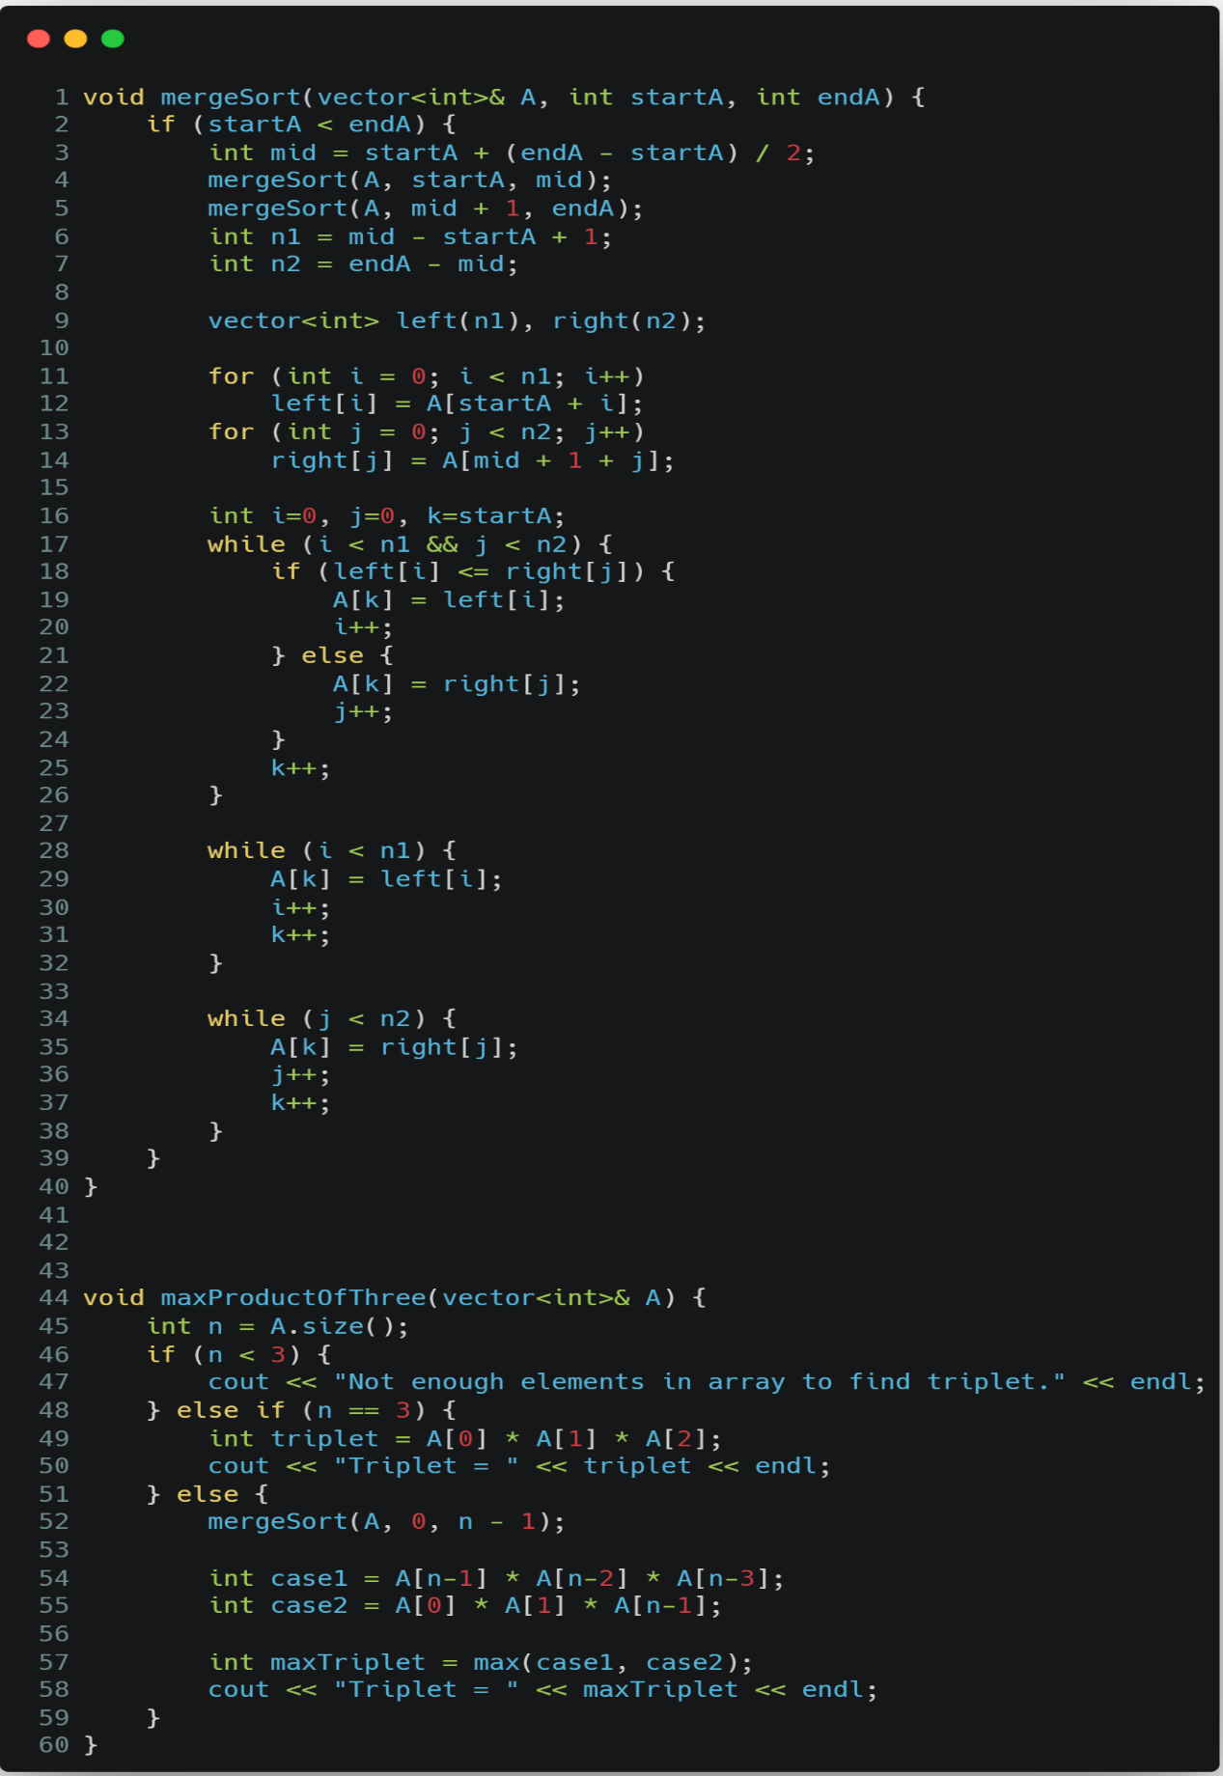
3] Analysis & Complexity:
1) First Way
$T\left(n\right)=2 T\left(\frac{n}{2}\right)+n$
$T\left(\frac{n}{2}\right)=2 T\left(\frac{n}{4}\right)+ \frac{n}{2}$
$T\left(\frac{n}{4}\right)=2 T\left(\frac{n}{8}\right)+ \frac{n}{4}$
$T\left(n\right)=2 T\left(\frac{n}{2}\right)+n=2\left[2 T \left(\frac{n}{4}\right)+ \frac{n}{2}\right]+n=2^{2}T\left(\frac{n}{2^{2}}\right)+2n$
$=4\left[2 T \left(\frac{n}{8}\right)+ \frac{n}{4}\right]+2n=8 T\left(\frac{n}{8}\right)+3n$
$= 2^{3} T\left(\frac{n}{2^{3}}\right)+3n$
$T\left(n\right)=2^{k} T\left(\frac{n}{2^{k}}\right)+kn \frac{n}{2^{k}}=1$ $n=2^{k}$
$k= \log_{2}{n}$
Then : $T\left(n\right)= 2^{\log_{2}{n}} T\left(\frac{n}{2^{\log_{2}{n}}}\right)+{n log}_{2}{n }$
$=n T \left(1\right)+{n log}_{2}{n }$

Then, the complexity is : 𝚶($n\log{n}$)

2) Second Way
$T\left(n\right)=2 T\left(\frac{n}{2}\right)+n$
$a=2 b=2 F\left(n\right)=n$
$compare of n^{\log_{b}{a}} and F\left(n\right)$

$n^{\log_{b}{a}}= n^{\log_{2}{2}}=n$ Then : $n^{\log_{b}{a}}= F\left(n\right)$
This is case 2 :

Then, the complexity is : 𝚶($n^{\log_{b}{a}}\log{n}$)
𝚶($n\log{n}$)

Third Algorithm (non-recursive) :
1] Pseudo code:
function maxTripletProduct(A) {
N <- length(A)
if N < 3
return "the numbers are less than 3 elements"
for (i <- 0; i < N - 1; i++) {
for (j <- 0; j < N - i - 1; j++) {
if (A[j] > A[j + 1]) {
swap(A[j], A[j + 1]);
}
}
}
a <- A[N - 1] * A[N - 2] * A[N - 3];
b <- A[0] * A[1] * A[N - 1];
return max(a, b);
}

2] Implementation:

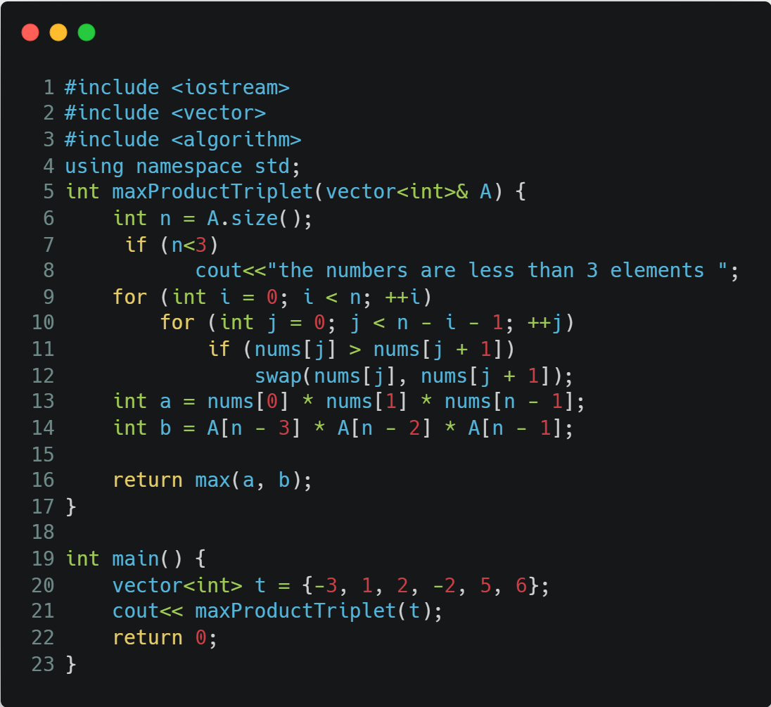

3] Analysis & Complexity:

$T\left(n\right)= \sum_{i=0}^{n-1}{ \sum_{j=0}^{n-i-2}{1= \sum_{i=0}^{n-1}{n-i-2}}}$
$= \frac{(n-1)(n)}{2} = \frac{n^{2}-n}{2}$

$Then$ , the complexity is : 𝚶( $n^{2}$ )

comparison :

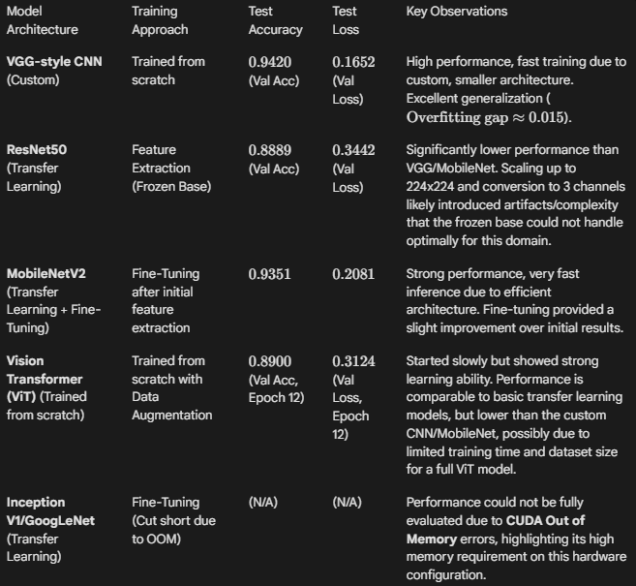

Pros and Cons of Each Architecture:
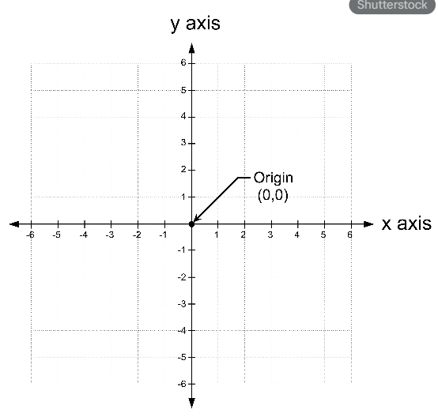

Pros and Cons of Model Architectures:
